SIMATS ENGINEERING (SAVEETHA SCHOOL OF ENGINEERING)
Department of Computer Science and Engineering
Assesment-CO1-AT3(Program)
==================================================================
Name: Hemanth P
Reg No :192472285
Course Code: DSA0310
Course Name: Natural Language Processing

QUESTION 1: INTELLIGENT EMAIL AND PASSWORD VALIDATOR USING REGULAR EXPRESSIONS
import re

# Email validation
def validate_email(email):
pattern = r'^[A-Za-z][A-Za-z0-9._]*@[A-Za-z]+\.(com|org|edu|net|in)$'
return re.fullmatch(pattern, email) is not None

# Password validation
def validate_password(password):
if len(password) < 8:
return False

if not re.search(r'[A-Z]', password):
return False

if not re.search(r'[a-z]', password):
return False

if not re.search(r'[0-9]', password):
return False

if not re.search(r'[@#$%&!]', password):
return False

return True

# Mobile number validation
def validate_mobile(mobile):
pattern = r'^[6-9][0-9]{9}$'
return re.fullmatch(pattern, mobile) is not None

# Main program
email = input("Enter email address: ")
password = input("Enter password: ")
mobile = input("Enter mobile number: ")

if validate_email(email):
print("Valid Email")
else:
print("Invalid Email")

if validate_password(password):
print("Strong Password")
else:
print("Weak Password")

if validate_mobile(mobile):
print("Valid Mobile Number")
else:
print("Invalid Mobile Number")
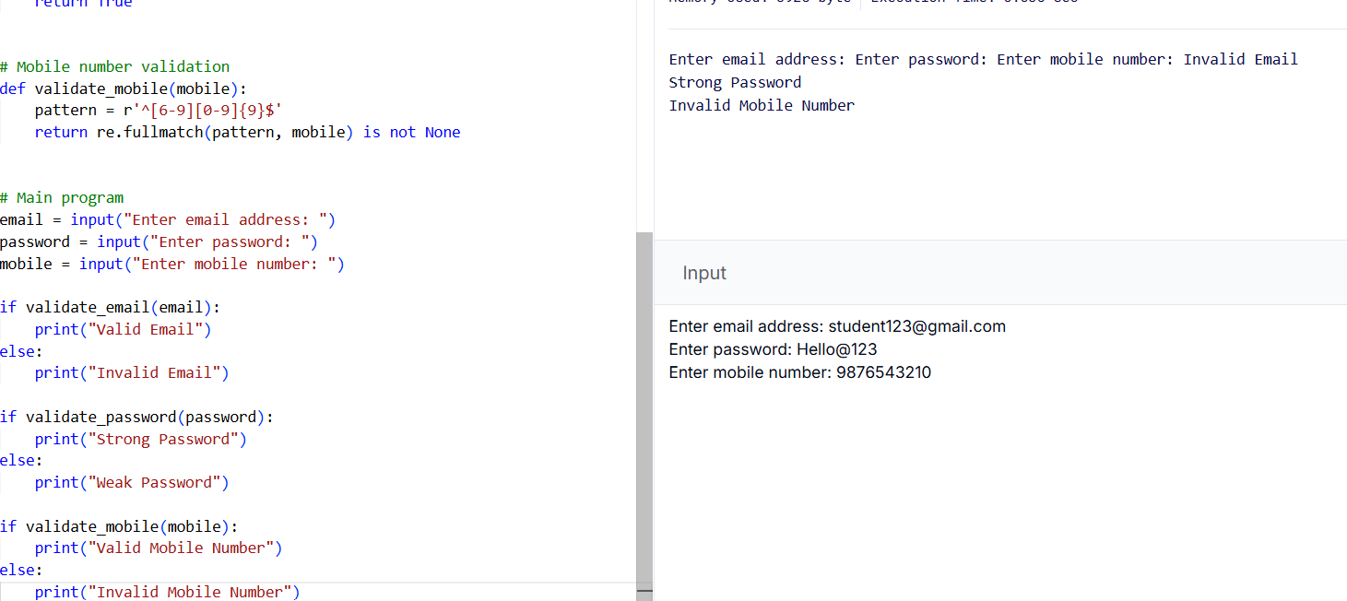
QUESTION 2: DESIGN A FINITE STATE AUTOMATA (FSA) SIMULATOR
# DFA Simulator

states = input("Enter states separated by spaces: ").split()
alphabet = input(
"Enter input alphabet symbols separated by spaces: "
).split()

transition = {}

print("\nEnter transitions:")

for state in states:
for symbol in alphabet:
next_state = input(
f"From {state} on {symbol}, go to: "
).strip()

if next_state not in states:
print("Invalid state entered!")
raise SystemExit

transition[(state, symbol)] = next_state

initial_state = input("\nEnter initial state: ").strip()

final_states = input(
"Enter final states separated by spaces: "
).split()

# Validate initial and final states
if initial_state not in states:
print("Invalid initial state!")
raise SystemExit

if not set(final_states).issubset(set(states)):
print("Invalid final state!")
raise SystemExit
number = int(input("\nHow many strings to test? ")

for i in range(number):
string = input(f"\nEnter string {i + 1}: ")
current_state = initial_state
path = [current_state]
valid Tru
for symbol in string:
if symbol not in alphabet:
valid = False
break
key = (current_state, symbol)
if key not in transition:
valid = False
break
current_state = transition[key]
path.append(current_state)
print("Transition Path:", " -> ".join(path))
if valid and current_state in final_states:
print("Accepted")
else:
print("Rejected")
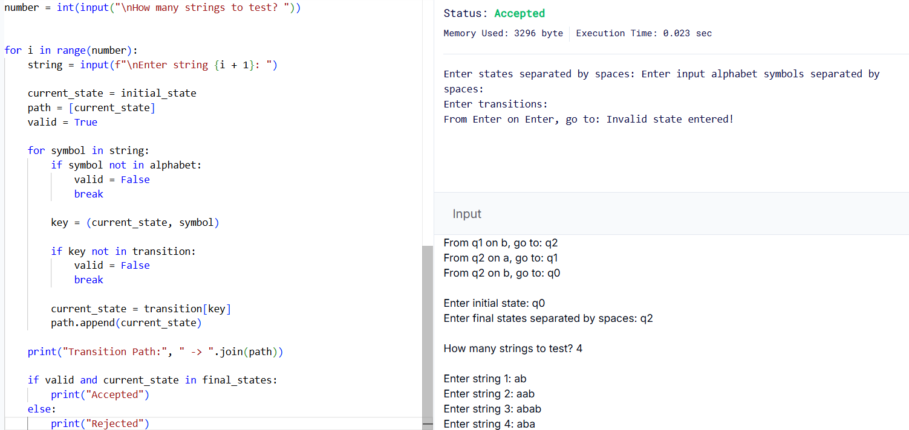
QUESTION 3: SMART PATTERN MATCHING ENGINE USING REGULAR EXPRESSIONS
import re

# Sample text
text = """
Meeting on 12/09/2026
Call 9876543210
#NLP
@OpenAI
natural language processing
The natural world is beautiful.
Processing is important.
"""

def search_pattern(pattern):
matches = re.findall(pattern, text)

if matches:
print("Matches found:")
for match in matches:
print(match)
else:
print("No matches found.")

while True:
print("\n--- Smart Pattern Matching Engine ---")
print("1. Search Date")
print("2. Search Phone Number")
print("3. Search Hashtag")
print("4. Search Mention")
print("5. Search Prefix")
print("6. Search Suffix")
print("7. Search Word")
print("8. Exit")

choice = input("Enter your choice: ").strip()

if choice == "1":
pattern = r'\b\d{2}/\d{2}/\d{4}\b'
search_pattern(pattern)

elif choice == "2":
pattern = r'\b[6-9]\d{9}\b'
search_pattern(pattern)

elif choice == "3":
pattern = r'(?<!\w)#[A-Za-z0-9_]+'
search_pattern(pattern)

elif choice == "4":
pattern = r'(?<!\w)@[A-Za-z0-9_]+'
search_pattern(pattern)

elif choice == "5":
prefix = input("Enter prefix: ").strip()

if prefix:
pattern = r'\b' + re.escape(prefix) + r'\w*'
search_pattern(pattern)
else:
print("Prefix cannot be empty.")

elif choice == "6":
suffix = input("Enter suffix: ").strip()

if suffix:
pattern = r'\w*' + re.escape(suffix) + r'\b'
search_pattern(pattern)
else:
print("Suffix cannot be empty.")

elif choice == "7":
word = input("Enter word: ").strip()

if word:
pattern = r'\b' + re.escape(word) + r'\b'
search_pattern(pattern)
else:
print("Word cannot be empty.")

elif choice == "8":
print("Exiting the program.")
break

else:
print("Invalid choice. Please try again.")
